Working with Gen Z/Running Start Students Resources

Article to read: https://www.mckinsey.com/industries/consumer-packaged-goods/our-insights/true-gen-generation-z-and-its-implications-for-companies

Youtube Videos
https://www.youtube.com/watch?v=cN0hyudK7nE
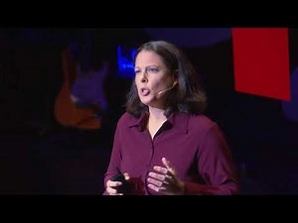 | Generation Z: Making a Difference Their Way | Corey Seemiller | TEDxDayton  As a college professor, Corey noticed a change in her newest college students--Generation Z. Her research has led her to uncover how this generation challenges the norms of our current society, and what promises that might hold for the future. Corey Seemiller is an educator, researcher and author on issues related to leadership and civic ...  www.youtube.com
https://www.youtube.com/watch?v=N5Y8W0OC9Jw
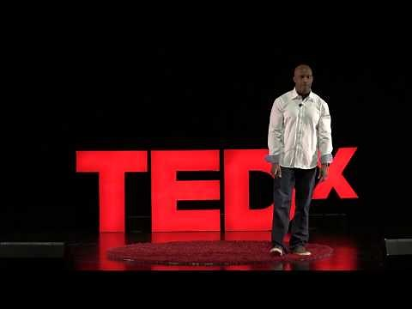 | We Owe Generation Z an Apology Today | Nathaniel Turner | TEDxHobartHighSchool  We need a plan of action for tomorrow. Generation Z is not at fault for their failures. Nate Turner explains accountability from all other generations. Nathaniel A. Turner was born and raised in Gary, Indiana. Despite graduating in the bottom quarter of his high school class from one of the worst and most impoverished school systems in the ...  www.youtube.com

https://www.mckinsey.com/industries/consumer-packaged-goods/our-insights/true-gen-generation-z-and-its-implications-for-companies
Generation Z characteristics and its implications for companies | McKinsey
Generation Z characteristics center around the search for truth as the influence of the first generation of true digital natives is now radiating outward. For companies, this will bring both challenges and equally attractive opportunities.
www.mckinsey.com

